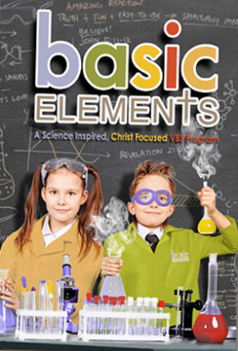
First Evangelical Church
of San Gabriel Valley
3658 N. Walnut Grove Ave, Rosemead, Ca. 91770

July 9-13, Monday – Friday
5:00-7:30pm

Be on time! Arrive at 4:45pm

Preschool – 5th Grade

It’s FREE!
But must register by Sunday, June 24.

QUESTION? Contact En Poli at en.poli@fecsgv.org

主題:基本化學元素--以基督為中心的暑假聖經學校即將開始了,今年全部免費大優待!
時間:7月9-13日(週一至週五) 5:00~7:30PM
要準時！到達下午4:45
報名截止日: 6月17日(星期日)
請至E3教室前索取詳細資料,或上網查詢

DAILY SCHEDULE

5:00-5:35pm – Praise Celebration and Skit
5:35-6:00pm – Science Experiment 1
6:00-6:15pm – Snack
6:15-6:45pm – Science Experiment 2
6:45-7:30pm – Science Project

First Evangelical Church of San Gabriel Valley
3658 N. Walnut Grove Ave, Rosemead, Ca. 91770

July 9-13, Monday – Friday, 5:00-7:30pm

Be on Time: Arrive at 4:45pm

It’s FREE!
But must register by Sunday, June 24.

Preschool – 5th Grade
適合幼稚園至5年級的孩童

QUESTION? Contact En Poli at en.poli@fecsgv.org

Father (父亲): | Cell#:
Mother (母亲): | Cell#:
Children (孩子): | Grade (级):
1.

2.

3.

